Project Design Phase-II Technology Stack (Architecture & Stack)

|  |  |
| --- | --- |
| Date | 18 October 2022 |
| Team ID | PNT2022TMID31222 |
| Project Name | Classification of Arrhythmia by Using Deep Learning with 2-D ECG Spectral Image  Representation |
| Maximum Marks | 4 Marks |

**Technical Architecture:**

The Deliverable shall include the architectural diagram as below and the information as per the table1 & table 2

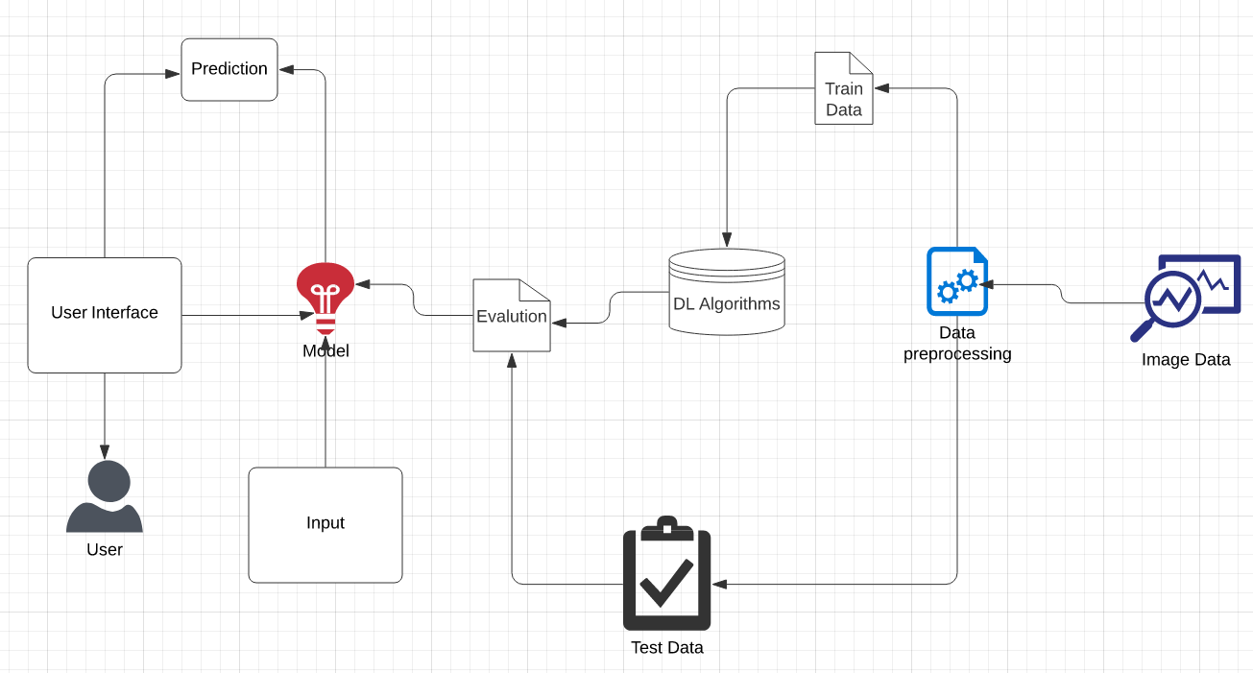

**Table-1 : Components & Technologies:**

|  |  |  |  |
| --- | --- | --- | --- |
| **S.No** | **Component** | **Description** | **Technology** |
| 1. | User Interface | How user interacts with the application - Web UI | HTML, CSS, JavaScript, etc. |
| 2. | Application Logic | The ECG signal was transformed into a 2-D representation, and a 2-D  CNN algorithm was used for classification. | Python |
| 3. | Database | Data Type, Configurations etc. | MySQL |
| 4. | Cloud Database | Database Service on Cloud | IBM DB2, IBM Cloudant etc. |
| 5. | File Storage | File storage requirements | Local Filesystem |
| 6. | External API | Defines communication between each requests and responses. | Flask(python), Keras, Tensorflow |
| 7. | Machine Learning Model | Training and testing. | CNN |

**Table-2: Application Characteristics:**

|  |  |  |  |
| --- | --- | --- | --- |
| **S.No** | **Characteristics** | **Description** | **Technology** |
| 1. | Open-Source Frameworks | Open source software is that by which the source  code or the base code is usually available for modification or enhancement. | Flask(python) |
| 2. | Security Implementations | By placing a filtration barrier between the targeted server and the attacker, the WAF is able to protect  against attacks like cross site forgery, cross site scripting and SQL injection. | SHA-256, Encryptions, IAM Controls,etc. |
| 3. | Scalable Architecture | Does not affect the performance even though used by many users. | Django or Flask |
| 4. | Availability | Anyone who is authorised. | Flask |

|  |  |  |  |
| --- | --- | --- | --- |
| 5. | Performance | Design consideration for the performance of the  application (number of requests per sec, use of Cache, use of CDN’s) etc. | Neo Load |
|  |  |  |  |